Week 1 Report: Transforming Wireframe into Static Web Page
Project Name: TechNova Landing Page
Developer: Intern
Submission Date: August 2026
1. Executive Summary
This report documents the design decisions, technical architecture, and problem-solving strategies applied during the creation of the TechNova static landing page. The primary goal of this task was to translate a wireframe layout into a functional, pixel-perfect, and fully responsive static webpage using semantic HTML5 and CSS3.
The resulting web page serves as a modern agency landing page featuring a structured header, hero section, about section, service grid, statistics counter, client testimonials, contact form, and footer.
2. HTML5 Architecture & Design Hierarchy
The web page's structural foundation was built using clean HTML5 semantic elements to maximize search engine visibility, accessibility, and code readability:
- Header & Navigation (<header>, <nav>): Contains the brand name "TechNova" alongside smooth-scrolling anchor links (#home, #about, #services, #contact) to facilitate single-page navigation.
- Hero Section (<section class="hero">): Structured with a two-column division split into hero-text and hero-image to maintain visual balance between the primary value proposition and graphic asset.
- Content Modules (<section>): Organized cleanly into modular sections:
  - about: Text section outlining company focus.
  - services: Feature cards integrated with Font Awesome v6.6.0 vector icons.
  - stats: Visual metric boxes highlighting achievements.
  - testimonials: User reviews enclosed within stylized cards.
  - contact: Accessible contact form featuring full-width text inputs and message textareas.
- Footer (<footer>): Simple copyright notice anchoring the bottom of the page.
3. CSS3 Styling, Layout Strategy & Micro-interactions
The visual styling was crafted using CSS3 to establish a modern, tech-forward brand identity:
- Color Palette: Built around deep corporate blues (#1e3a8a), vibrant call-to-action blues (#2563eb), slate accents, and light gray background contrast (#f4f7fc).
- Flexbox Layout Engine: Flexbox was used extensively across the header navigation, service card grids, statistic blocks, and testimonial section to ensure flexible item distribution.
- Interactive Feedback: Applied smooth CSS transition properties (0.3s) on button hovers, link highlights, and subtle card elevation transforms (transform: translateY(-8px)) to provide intuitive micro-feedback to user actions.
- Global Reset: Implemented a universal CSS reset (* { margin:0; padding:0; box-sizing:border-box; }) to ensure uniform element dimensions across different browser rendering engines.
4. Responsiveness & Media Queries
To ensure the landing page renders fluidly on desktops, tablets, and smartphones, media queries targeting small viewports (max-width: 768px) were integrated:
- Stacking Behavior: Multi-column flex containers (header, services, testimonials, and statistics) shift dynamically from row orientation to vertical columns (flex-direction: column) on narrower screens.
- Typography Scaling: Heading sizes are scaled down (e.g., hero titles drop from 60px to 38px) to prevent text clipping or horizontal scrollbar glitches on mobile devices.
- Container Fluidity: Card component widths adapt from fixed lengths (300px / 350px) to fluid width percentages (width: 90%) on smaller display environments.
5. Challenges Encountered & Problem Solving
- Jumpy Jump-Link Scrolling:
  - Issue: Clicking header navigation links created abrupt visual cuts to different page sections.
  - Solution: Applied scroll-behavior: smooth; directly to the html element for smooth scrolling effects.
- Hero Image Alignment:
  - Issue: Text and image scaling caused misalignment on medium-sized screens.
  - Solution: Assigned equal flex distribution (flex: 1) to both hero-text and hero-
  - image wrapper classes.

6 . Screenshot

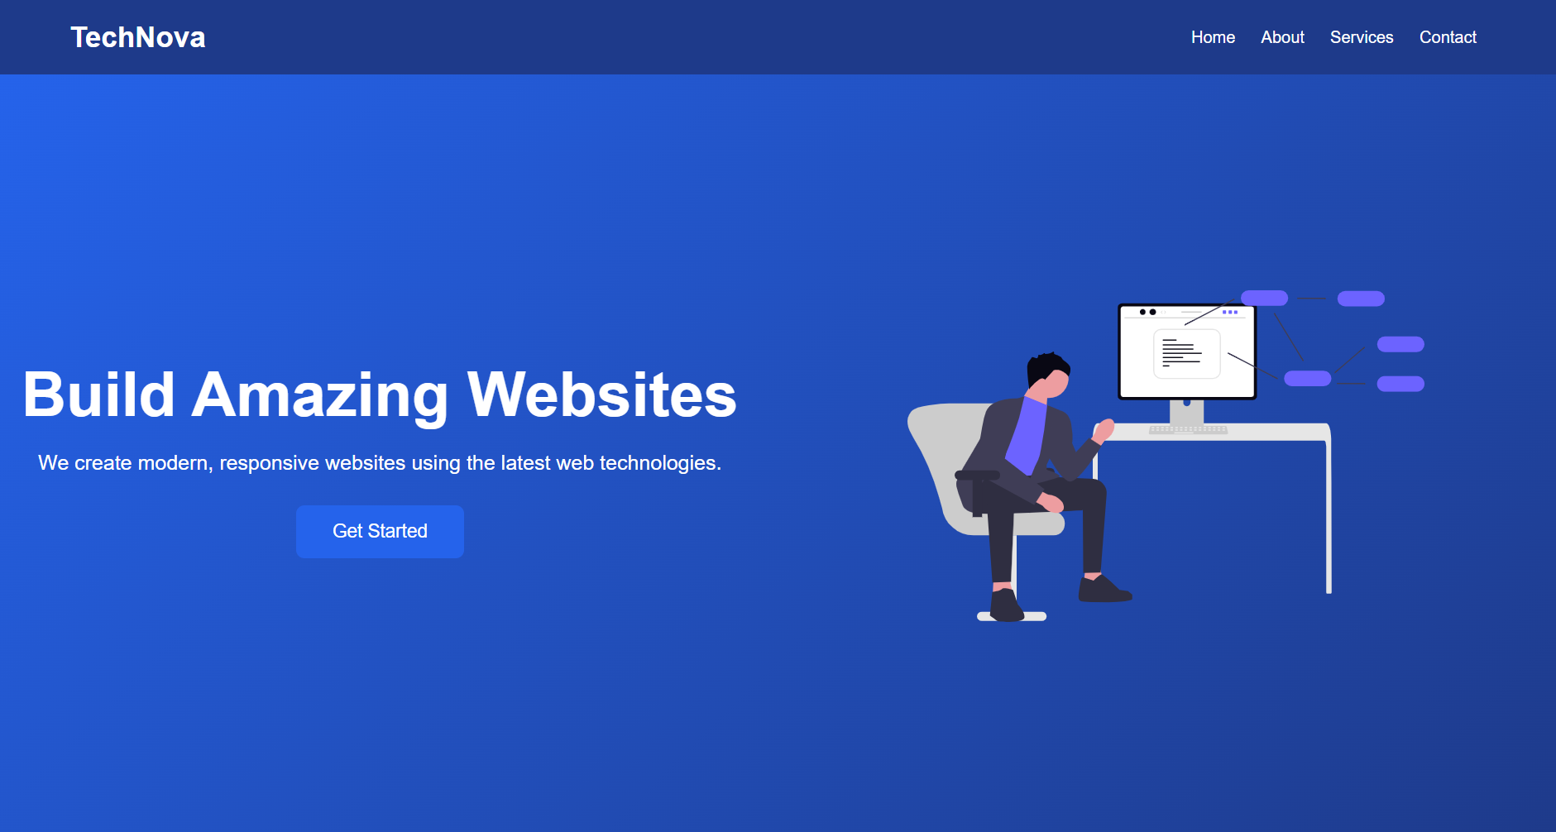

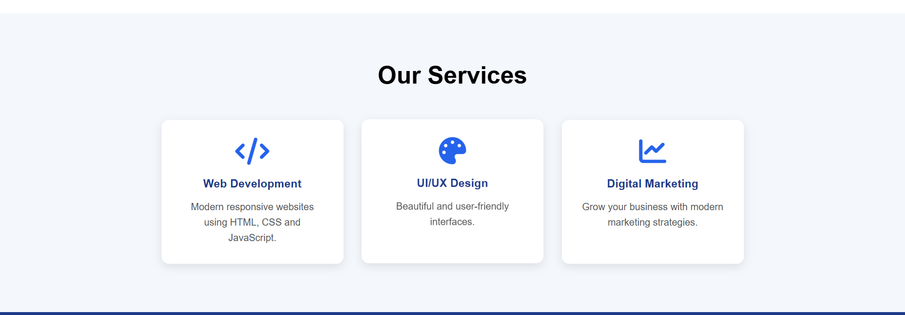

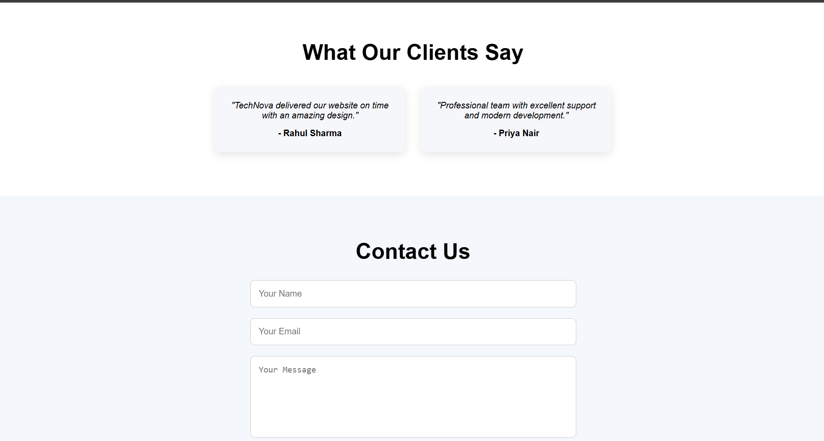

7. Conclusion
The developed TechNova webpage meets all structural, aesthetic, and functional wireframe requirements. The implementation demonstrates proficiency in modern HTML5 semantic markup, structured CSS styling, flexbox layouts, and responsive design techniques.

